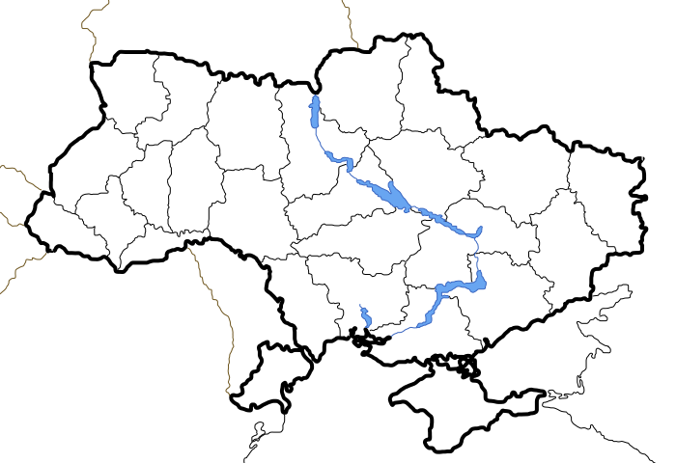

Carpathian Mts.

Donets River

Belarus

Dnieper River

Crimean Peninsula

Ukraine

Moldova

Poland

Black Sea

Sea of Azov

RUSSIA

Odessa

Yalta

Chernobyl

Kiev